AJ, ZELENA JE
Bela Krajina, Slovenia
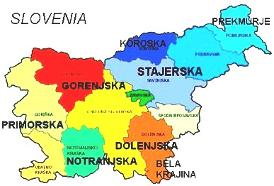
The people of Bela Krajina (part of Dolenjska Region) are descendants of the Slovene settlers from the middle Ages and the South Slavic refugees who fled from the Turks and started to settle here at the beginning of the 16th century. The region of Bela Krajina is today known for its national, linguistic and religious diversity. Slovenes and Croats live here, speaking Slovene and Croatian dialects respectively. Dances from Bela Krajina region are the oldest dances in Slovenia and there are noticeable influences of the neighboring Croatia. Bela Krajina is the only region in Slovenia where a round dance "kolo" is danced. This dance is also called “Črnomaljsko kolo”.
Željko attended several celebrations from 1976-1984 in the cities of Črnomelj, Novo Mesto and Metlika.

TRANSLATION: It is green

PRONUNCIATION: Ahee Zay-lay-NAH Yeh

MUSIC: 2/4 meter CD: “Željko Jergan’s Dance Journey” Band 19
Cassette: Croatian Folk Dances Vol. 3

FORMATION: Closed circle, alternating M & W facing ctr. Hands are joined down ("V" pos). If just girls are dancing they hold a handkerchief between each other.

STYLE: Heavy, earthy walking steps, with slight sway in turns

Meas PATTERN

INTRODUCTION: 2 meas, no action.
Pattern:
1 - 4 Pause (ct 1), starting with right foot, walk 7 steps in LOD (CCW).
5 - 7 Balance on L to L, step on R in place, turning to face center. Starting on L, walk 4 steps into center.
8 - 10 Balance on L to L, step on R in place. Starting on L walk 4 steps straight back.
11 - 14 Balance on L to L, step on R in place turning to face LOD. Starting on L walk 6 steps in LOD.
15 - 24 Repeat meas 5 - 14.
25 - 30 Repeat meas 5 - 10, stopping in place on final step back.
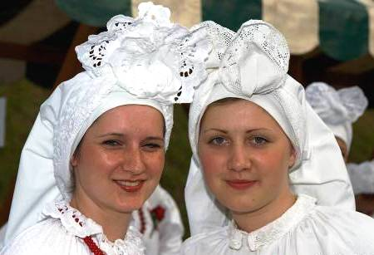
Aj, zelena je - Pg 2

Črnomaljsko kolo

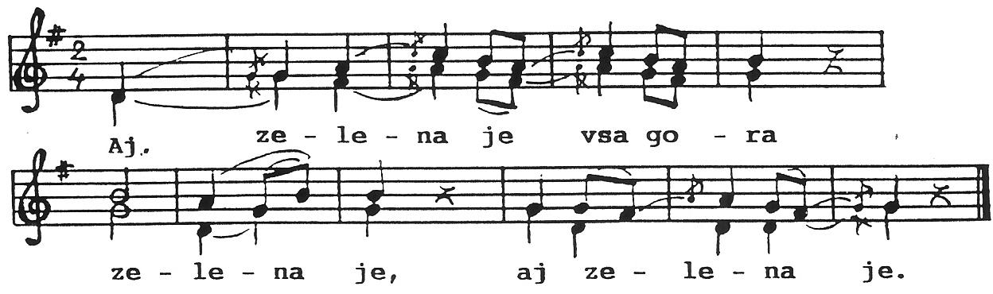
Aj, zelena je vsa gora, zelena je, aj zelena je.
Aj notri raste trava diteljina, aj notri raste.
Aj, žela jo je spremlada devojka, aj žela jo je.

The hills are green, really green.
The clover is covering all of the hills.
Young girl is harvesting the clover.
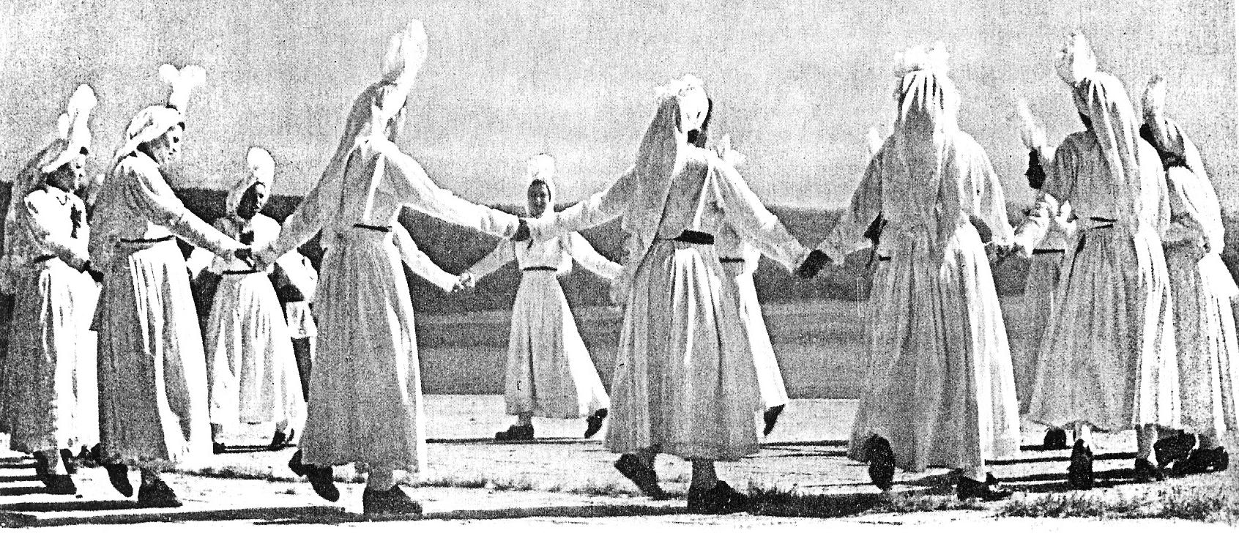

Presented by Željko Jergan Dance notes by Željko Jergan and Cricket Raybern, May 2010

